
The Islamia University of Bahawalpur

Assignment # 2 | Theory of Computation

A Summary on the Article: Scientific Reference Style using rule-based machine learning

By: Jawwad Ahmad | F25NDOCS3W04013 | MSCS 2nd

Article Link:
https://ijain.org/index.php/IJAIN/article/view/1056

Instructor

Sir. Muhammad Majid

Executive Summary
The authors propose an automated system to convert scientific reference entries from one citation style to another using rule-based machine learning and regular expressions. In the context of academic writing, references follow varied formatting conventions (APA, IEEE, MLA, Harvard, Springer, etc.), and manually reformatting references is time-consuming. The study introduces a pipeline that first classifies each reference’s style and then extracts its fields to reassemble it in a new style. Specifically, they deploy a Bayesian (probabilistic) classifier to predict the reference format based on features like author name, publication year, title, publisher, and page numbers. Regular-expression rules are crafted to match and restructure these components. Evaluation showed the classifier accurately identifies features (e.g. ~85% for author names, ~90% for years). Conversion accuracy was moderate (≈57% correctly converted) across books and journals, with string-similarity metrics (97.8% similarity) indicating close matches to target formats. The system performs best on consistent styles (IEEE, APA) and less well on styles with high variability (MLA, Harvard). In conclusion, the rule-based approach effectively automates reference style changes and yields high precision for many cases, thus enhancing the efficiency and adaptability of academic publishing.

Input
- Data sources: A corpus of 1500 reference entries was compiled from published works (academic papers, journals, conference proceedings, books) covering seven citation styles. Each entry is assumed to be a complete reference string in one of the target styles.
- Sample size: 1500 total references (used for training and evaluation).
- Citation styles (classes): Seven formats, including APA, IEEE, MLA, Harvard, Chicago, Springer (and Springer LNCS). Data presumably include a mixture of each style, but exact class distribution is unspecified.
- Variables/Features: For each reference, key metadata fields were identified: author name, publication year, title, publisher, and page numbers (denoted as “paper_page”). These constitute feature classes for classification.
- Inclusion criteria: References conforming to the seven specified styles (APA, IEEE, MLA, Harvard, Chicago, Springer) were included. Other formats were excluded (unspecified). Non-text references or incomplete entries were presumably omitted (details not provided).
- Preprocessing: Each reference string was processed to label feature spans. The five fields (author, year, etc.) were manually tagged in the training data for precise model building. No additional data cleaning steps are reported.

Processing
Key steps include:
- Feature labeling and training: The manually labeled dataset (1500 entries with tagged fields) was used to train a Bayesian classifier (Naïve Bayes) implemented with the Weka toolkit. The training set was used to learn probability distributions of feature patterns per style.
- Reference style classification: For a new reference, the classifier calculates the probability of each style given the observed features. The model treats the labeled features as a “bag of words” and predicts the reference style (APA, IEEE, etc.). A Bayesian probability model (likely multinomial Naïve Bayes) is used, assuming conditional independence of features.
- Feature extraction: Independently, regular expressions are applied to parse the reference string and extract metadata fields (author, year, title, publisher, pages). These regex patterns were derived from known style rules (patterns of punctuation, ordering, keywords, etc.). For example, capturing author names before a period or year in parentheses, etc. The extraction model’s performance was evaluated by computing string distances to the ground truth.
- Conversion engine: Given the identified style and extracted fields, a set of RegEx-based formatting rules reconstructs the reference in the target style. For example, reordering fields, adding punctuation and abbreviations according to IEEE or APA templates. The system can convert any detected input style into any of the supported target styles.
- Validation and metrics: Performance was measured using: (1) Accuracy for style classification (percentage of references assigned the correct style label); (2) Levenshtein distance (edit distance) between the system output and the correct reference text; and (3) Similarity ratio (a normalized match score close to 1 for exact matches). For classification, confusion matrices were. The Bayesian model achieved high feature-label accuracy (e.g. 85.5% for author, 90.9% for year, etc.).
The processing pipeline can be summarized by the following flowchart:
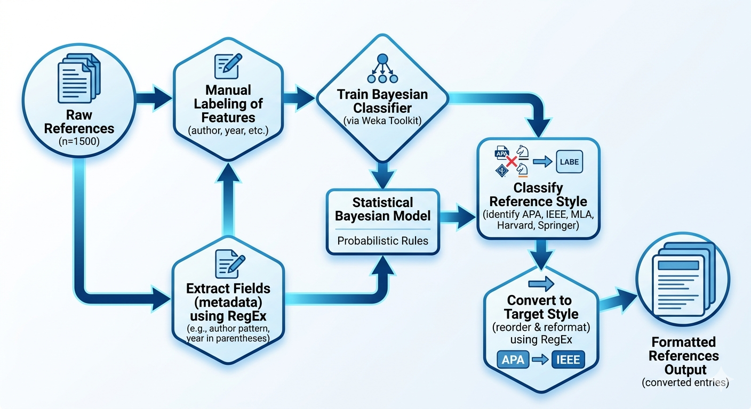

Output
Results and metrics: The system produced both quantitative metrics and qualitative outputs:
- Classification accuracy: The Bayesian model’s style predictions varied widely by style. As shown in the confusion analysis, the highest accuracy was for IEEE (~88.1%) and APA (~81.7%), indicating those styles were correctly identified in most cases. In contrast, MLA and Harvard styles were identified with only ~23–25% accuracy, likely due to their variability. Intermediate accuracies were observed for Chicago (~77.6%) and Springer (~62.1%). Overall, the classifier effectively distinguishes consistent formats but struggles with less regular ones.
- Feature extraction accuracy: For the hand-labeled features, the system achieved ~85.5% accuracy on author names, ~90.9% on years, ~74.8% on titles, ~62.2% on publishers, and ~82.7% on page numbers. These values come from the feature-wise confusion matrix (Fig.2). The lower scores for publisher and title indicate some errors in segmentation.
- Conversion performance: When converting references, the model attained a 97.8% similarity ratio (Levenshtein distance = 2) on average for journal references. The APA style for journals produced the best match (99.97% similarity, distance 1). For book references, accuracy was 57.26%, and for journal references 57.56%, reflecting the percentage of exactly correct conversions. These metrics suggest most output references were very close to correct (high similarity), even if some edits were needed.
- Outputs: The system generates reformatted reference strings as output; the paper illustrates examples of converted references (e.g. APA-to-IEEE) and reports numerical metrics in tables (e.g. accuracy scores for each style, error distances, etc.). It also provides confusion matrices (Fig.2 and Fig.3) to summarize classification results.

Comparison Table
Citation Style | Classification Accuracy | Stability Level
IEEE | 88.10% | High (Numerical, very consistent)
APA | 81.70% | High (Author-date, structured)
Chicago | 77.60% | Medium (Consistent but shares patterns)
Springer | 62.10% | Medium (Standardized but varies by sub-series)
Harvard | 24.50% | Low (High regional/institutional variation)
MLA | 23.70% | Low (Frequent updates and stylistic flexibility)

